The decision to write the summary on this specific paper came from my personal interest in the NBA franchise and the sport of basketball as a whole. The paper specifically tackles the NBA play-offs of the 2009/2010 season, specifically the first round where the games were considered as networks, the players as nodes, and the ball movement as links. Through this network properties such as degree centrality, clustering, entropy and flow centrality across teams and positions were analyzed. This was done to see if would be possible to observe any differences in each team’s strategies when on the offense via the use of their network properties.

In order to evaluate basketball teams as networks, player positions and inbound/outcomes were considered as nodes, and ball movement about nodes, including any shots, were considered as edges. The sequences of ball movement for each of the 16 teams in the play-offs were recorded across two of the games that each team played. This data was used to determine whether it is possible to capture basketball as a whole via the use of a transition network represents the average flow of the ball through these sequences. The data was then also used to see if these different teams had specific network signatures. In order to make use of the player positions as nodes, the five starting players for each team in the play offs were assigned numbers based off the position that each player plays. For instance, Point Guard was 1, Shooting Guard was 2 and so on. The only offensive plays that were used for research were the ones that included at least a minimum of 3 from the starting players, the rest were not used. Preliminary analyses showed us that offensive play paths were relatively the same for the two games that the majority of the teams played and as such sequences were pooled.

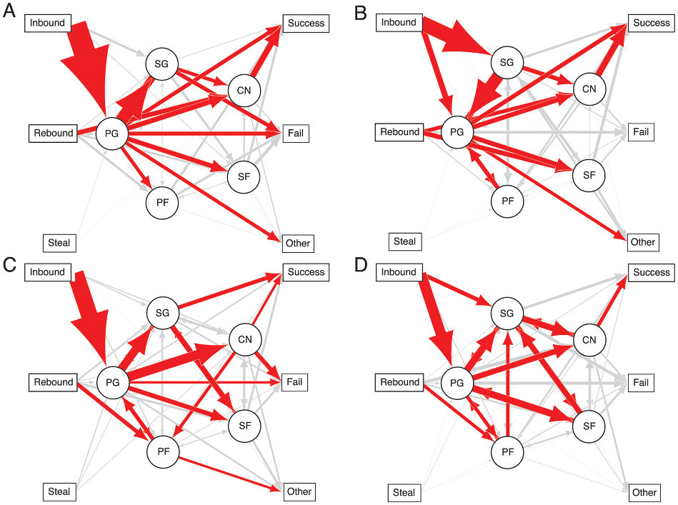

In the figure above one can see the weighted graphs of ball transitions across two games for 4 teams which participated in the play-offs, the Bulls(A), the Cavaliers(B), the Celtics(C), and the Lakers(D). The edge width is proportional to the probability of transition between the nodes. Red edges represent transition probabilities summing to the 60th percentile. The importance of the Point Guard in the distribution of the ball identifies this as the primary leadership position in the team network. If leadership is taken as the relative importance of the player/position in a network, then we can capture this quantitatively via individual flow centrality, or the proposition of paths (the mentioned offensive plays) involving a particular node.

In conclusion, I chose this paper as it presents a network structure analysis of basketball teams in the context of team coordination and strategy. The study goes through more than a thousand different ball movements, and more than a hundred different sequences and paths for each team. Through this dataset they managed to capture the game of basketball as a network, yet a single network variable cannot capture multiple successful team strategies.